Call Wizard Process – Issues Oscar R.

City field accepts numbers and special characters in the Site Address step

Description
In the HUB Call Wizard Process, the City field under the Site Address step is accepting invalid input. The current result shows the city entered as “Sumter 123 %#”, which includes numbers and special characters.

Steps to Reproduce
- Open HUB.
- Go to Tool > Wizard.
- Complete the previous steps until reaching the Site Address step.
- In the City field, enter a value with numbers and special characters, for example: “Sumter 123 %#”.
- Observe that the field accepts the entered value.

Actual Result
The system allows the user to enter and keep a city value containing numbers and special characters.

Expected Result
The system should prevent the user from entering numbers and unsupported special characters in the City field, or display a validation message when invalid characters are entered.
Severity
Medium
Priority
High

State field redirects to application error page when invalid characters are entered

Description
In the HUB Call Wizard Process, under the Site Address step, the State field allows the user to enter invalid characters, such as numbers or unsupported special characters. When the user clicks Save Site & Continue to Pricing, the system redirects to an application error page instead of displaying a validation message on the form.

Steps to Reproduce
- Open HUB.
- Go to Tool > Wizard.
- Complete the flow until reaching the Site Address step.
- Enter valid information in the required fields, except for the State field.
- In the State field, enter an invalid value, for example: “S#” or any number/special character.
- Click Save Site & Continue to Pricing.
- Observe that the system redirects to an error page.

Actual Result
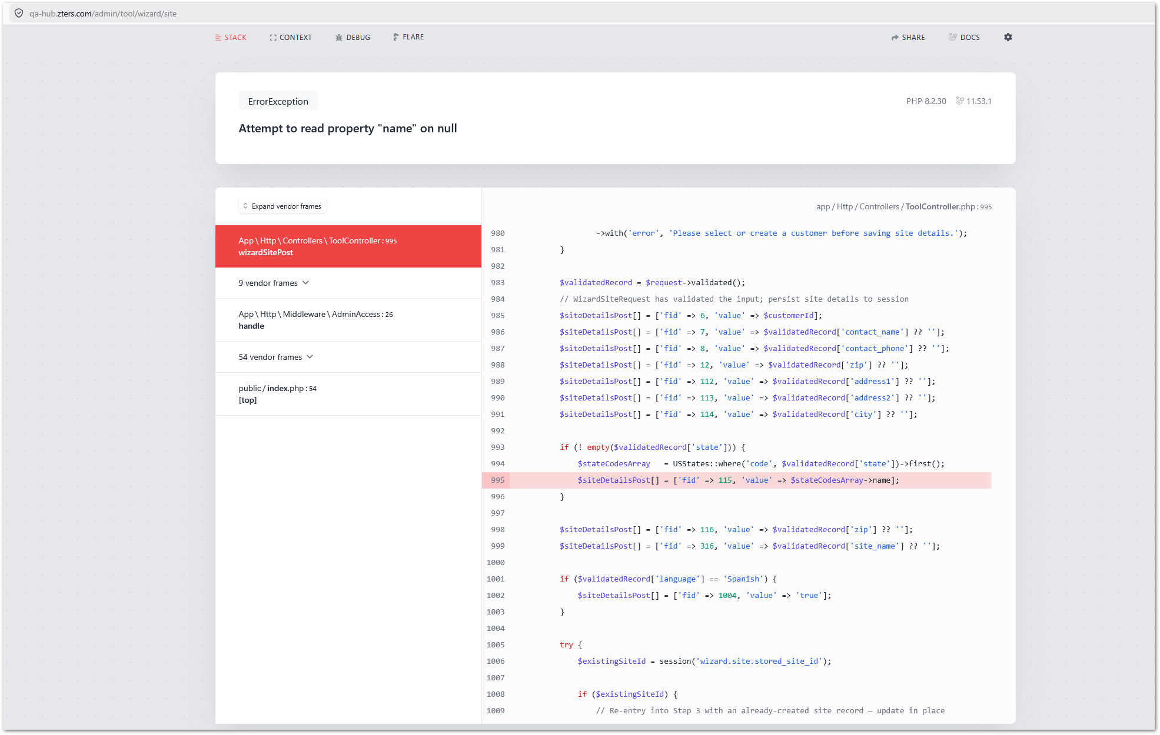
The system redirects the user to an error page after saving the form with an invalid value in the State field. The error page displays: “Attempt to read property ‘name’ on null”.

Expected Result
The system should not redirect the user to an error page. The State field should validate the entered value before submission and prevent invalid numbers or special characters.
Severity
High
Priority
High

Zip Code field displays validation only after more than 10 characters instead of more than 5 digits
Description
In the HUB Call Wizard Process, under the Site Address step, the Zip Code field allows the user to enter more than 5 digits. The system displays a warning message only when the ZIP code exceeds 10 characters, but the validation should trigger when the ZIP code is greater than 5 digits.
Since U.S. ZIP codes should follow a 5-digit format in this field, the system should not allow values such as “2920122222”.

Steps to Reproduce
- Open HUB.
- Go to Tool > Wizard.
- Complete the flow until reaching the Site Address step.
- Enter valid information in the required address fields.
- In the Zip Code field, enter a value with more than 5 digits, for example: “2920122222”.
- Observe the validation behavior.

Actual Result
The system allows the user to enter a ZIP code with more than 5 digits. A warning message is displayed only when the ZIP code is greater than 10 characters. Current warning message displayed:
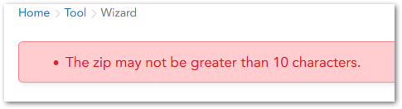

Expected Result
The system should validate the Zip Code field when the value is greater than 5 digits. The user should not be allowed to continue with a ZIP code that exceeds the expected 5-digit format. The message should be “Zip Code must contain exactly 5 digits.”

Severity
Medium

Priority
High

Customer notes do not persist when navigating back from Pricing to Site Address

Description
In the HUB Call Wizard Process, the Customer notes entered in the Call Notes panel do not persist consistently throughout the call flow. When the user adds Customer notes during the Site Address step and clicks Save Site & Continue to Pricing, the notes are displayed correctly on the Pricing page. However, if the user navigates back from Pricing to Site Address, the Customer notes field is empty.

Steps to Reproduce
- Open HUB.
- Go to Tool > Wizard.
- Complete the flow until reaching the Site Address step.
- In the Call Notes panel, enter a note in the Customer field.
- Enter a note in the Site field.
- Click Save Site & Continue to Pricing.
- Verify that both the Customer and Site notes are displayed correctly on the Pricing page.
- Navigate back from Pricing to Site Address.
- Observe the Call Notes panel again.

Actual Result
The Customer notes field becomes empty after navigating back from Pricing to Site Address. The Site notes field continues to display the previously entered note correctly.
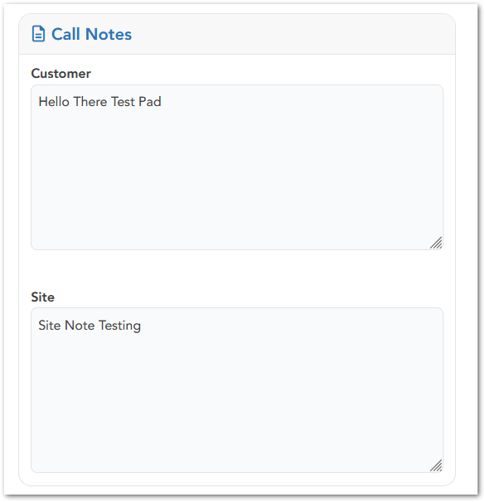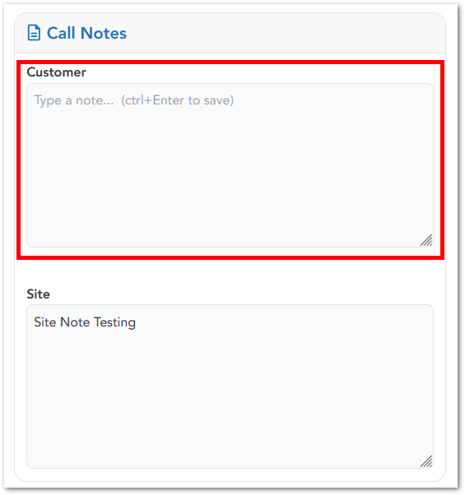

Expected Result
The Customer notes should persist when the user moves forward and backward through the call flow, the same way the Site notes persist. The user should not lose Customer notes after navigating between the Site Address and Pricing steps.
Severity
Medium
Priority
High

Placement Notes field remains highlighted as required after valid text is entered

Description
In the HUB Call Wizard Process, on the Pricing page, the Placement Notes field is highlighted in soft red because it is mandatory. However, after the user enters text in the field, the red required-field highlight remains visible.

Steps to Reproduce
- Open HUB.
- Go to Tool > Wizard.
- Complete the flow until reaching the Pricing page.
- In the quoted product section, locate the Placement Notes field.
- Enter any valid text in the field.
- Observe that the field remains highlighted in soft red.

Actual Result
The Placement Notes field remains highlighted as if it were still empty or invalid, even after text is entered.
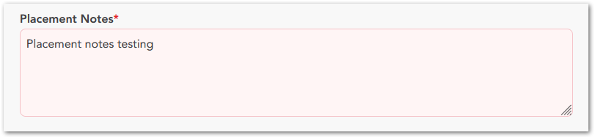

Expected Result
Once valid text is entered, the soft red required-field highlight should be removed.

Severity
Low

Priority
Medium

